AJIT GAYKAR






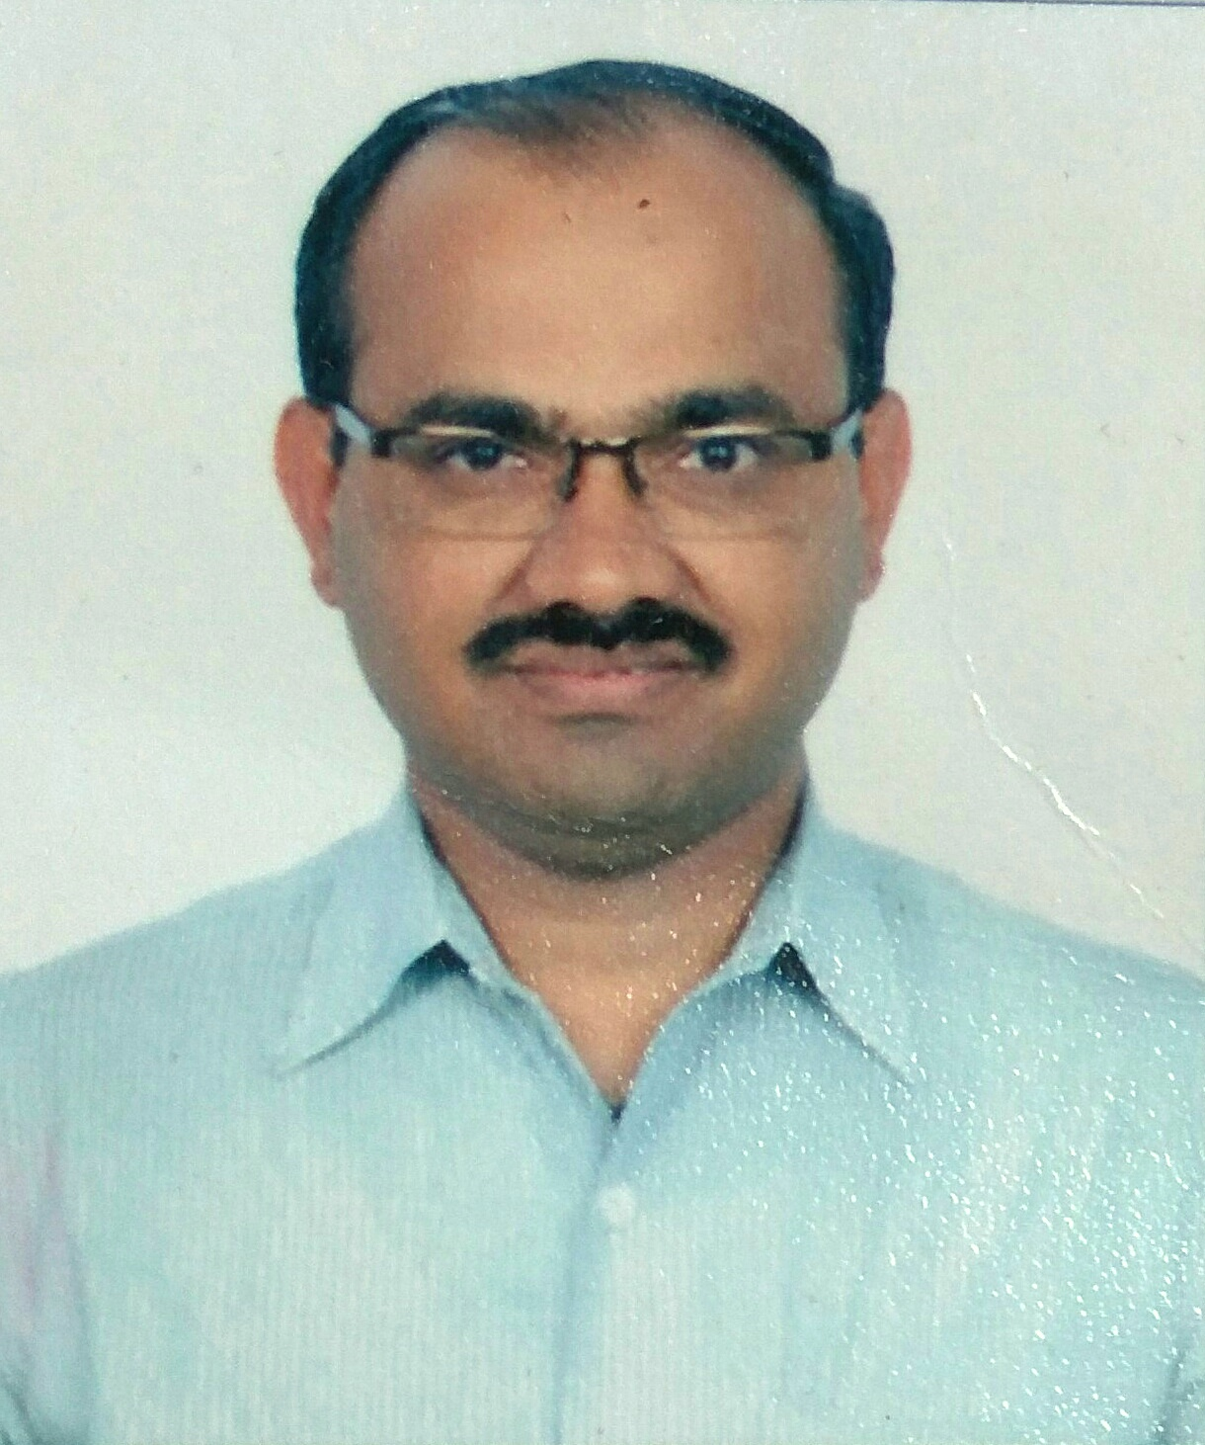
a.gaykar@cathedral-school.com

January 16, 1979
Mumbai, Maharashtra
+91 9969336298
15 Years’ Experience

ABOUT ME

PHYSICS TEACHER (Preferred Curriculum: IGCSE, IB)

Profile
I believe that quality education is essential to unlock the vast resources of human potential. I am currently teaching IBDP physics and have taught physics to IGCSE students since 2008 and my pupils have passed IGCSE with excellent grades every year. I like to analyse the strengths and weaknesses of my pupils and adapt my teaching methodology so as to make effective contributions to the all-round development of my pupils.

Education
Master of Science, Physics (Electronics)  Patkar College, University of Mumbai,  Maharashtra. | Graduated, October 2003  Marks 66%  Division I
Bachelor of Education  Oriental College of Education,  University of Mumbai, Maharashtra | Graduated, May 2003  Marks 65%  Division I
Bachelor of Science, Physics  Patkar College, University of Mumbai,  Maharashtra. | Graduated, May 1999  Marks 65%  Division I
HSC(Xll), Maharashtra State Board | Passed in May 1996  Marks 63%  Division I
SSC(X), Maharashtra State Board | Passed in May 1994  Marks 70%  Division I

Professional Affiliations

- Completed a professional development course on Teaching Critical Thinking and Problem Solving conducted by BRITISH COUNCIL connecting classrooms in Mumbai on 29th April 2016

- Completed a professional development course on An Introduction to Core Skills for Teachers conducted by BRITISH COUNCIL connecting classrooms in Mumbai on 29th April 2016.

- Participated in Workshop on Concept Based Curriculum conducted by MISA at JBCN International School in Mumbai on 17th August 2016.

- Participated in University Guidance Conference for Cambridge International Schools conducted at D.G. Khetan International. School in Mumbai on 15th November 2014.

- Completed the University of Cambridge International Examinations Online Professional Development course Introduction to Cambridge Primary on 30th June 2011

- Participated in a Stage 1 Introductory Course in International AS/A Level Physics (9702) conducted by University of Cambridge International Examinations at Singapore International School, India during April 2009.

Work Experience

Since June 2018
Facilitator for Physics (SL/HL)
Cathedral and John Connon School
6, Fort, Mumbai – 400001.
Facilitator of Physics for IBDP.
- Teaching physics to IBDP pupils of Year 1 and Year 2 as per (HL/SL) curriculum prescribed by I.B.
- Content development for physics as per IBDP syllabus for HL as well as SL. This includes preparation of worksheets, assignment sheets, question bank, power point presentations, resource material, question papers, solutions etc.

Since June 2008 to May 2018
Assistant Teacher (Sub: Physics)
Trinity International School, Sion (east),
MUMBAI, Maharashtra-400022.
Teacher of Physics for IGCSE, AS & A levels.
- Teaching physics to Checkpoint, IGCSE, AS & A levels as per curriculum prescribed by Cambridge International Examinations.
- Content development for physics as per CIE syllabus for Checkpoint, IGCSE, A & AS levels. This includes preparation of worksheets, assignment sheets, question bank, resource material, question papers, solutions etc.
Head of Department – Science, since June 2011.
- Planning, monitoring and moderating work of science teachers for Grade I to Grade VIII.
- Guiding teachers with respect to yearly planning of syllabus, Lesson planning, Preparation of study material, Question papers, Mark scheme, Corrections of answer sheets etc.
Since May 2011
Head Master
Trinity International school, Sion (east),
Mumbai, Maharashtra-400022.
Working as head master my responsibilities include.
- Planning and implementing school time table,
- Monitoring the day to day working of school,
- Planning and conducting assessment of pupils throughout the year,
- Interacting with parents regarding academics and other aspects of progress of a child,
- Monitoring collection of monthly school fees,
- Coordinating work related to Department of Education, Maharashtra State etc. with the help of other teachers and under guidance from the Principal of school.

June 2007 - April 2008
Assistant Teacher
St. John’s High School, Borivali(east), Mumbai, Maharashtra.
- Worked as teacher of Mathematics and Science for secondary section.
- Classes handled: Xth,IXth,VIIIth.
- School Affiliated to Maharashtra State Board and I.C.S.E.

June 2006 - April 2007
Assistant Teacher
Smt.J.B.Khot High School, Borivali(east), Mumbai, Maharashtra.
- Worked as teacher of Mathematics and Science for secondary section.
- Classes handled: Xth,IXth,VIIIth.
- School Affiliated to Maharashtra State Board.

June 2003 - April 2006
Assistant Teacher
St. John’s High School, Borivali(east) Mumbai, Maharashtra.
- Worked as teacher of Mathematics and Science for secondary section.
- Classes handled: Xth,IXth,VIIIth.
- School Affiliated to Maharashtra State Board.

Awards & Honors

- Awarded Certificate of Appreciation for SUPPORTING THE INTEGRATION OF INTERNATIONAL LEARNING IN THE CURRICULUM as part of INTERNATIONAL SCHOOL AWARD 2017-2020 by BRITISH COUNCIL UK/IN.

- Awarded Certificate of Appreciation for leading, guiding and managing the Misa Cell Meet for physics teachers (IGCSE and A& AS Levels) on 22nd July 2017.

- Presented a paper on Innovation in Education at the National Paper Presentation Seminar organised by Sanskar Vikas Society, held on 10th December 2016 at Pragnya Bodhini High School, Mumbai.

- Awarded Certificate of Appreciation for Facilitating the Misa cell meet for physics teachers (IGCSE and A& AS Levels) on30th July 2016

- Awarded Certificate of Appreciation for Facilitating the Misa cell meet for physics teachers (IGCSE and A& AS Levels) on 23rd July 2015 and on 22nd November 2015.

- MISA Synergy Annual Science exhibition 2015- IIIrd prize.

- MISA Synergy Annual Science exhibition 2013- IIIrd prize.

- Inter school R-East ward Annual Science Exhibition 2005-2006 Ist prize.

- Inter school R-East ward Annual Science Exhibition 2004-2005 IIIrd prize.

- Winner of inter college Elocution Competition held at Oriental College in 2003.

- Actively participated in students council of Oriental College in 2002-2003.

- Successfully completed the Beginner’s Course of Intel Tech to the future program in January 2003.

- Awarded Late Shri Prakash Dahanukar Prize by S.S. and L.S. Patkar College for passing B.Sc. Degree examination with Highest Marks in Physics

Computer Proficiency

- Word 2010
- Power Point 2010

Languages
- English
- Marathi
- Hindi

Personal Details

Permanent Address: 702, Charkop Shree Vinayak Co-op
Hsg. Soc., Plot No.272, Sector1
Charkop, Kandivali (west),
Mumbai 400067.
Mobile: +91 9969336298
E-mail: ajitgaykar@gmail.com.
Maritial status : Married

Declaration:
I, hereby declare that the information contained herein is true and correct to the best of my knowledge and belief.
It would be pleasure to be associated with your organization.
I am looking forward to establish a meaningful, growth oriented, symbiotic relationship with your esteemed organization.

Date: Yours Truly,

Place: Mr.Ajit R.Gaykar.

